Custom Offsets for GGD’s AR-15 and AR-10 Codes

(Alternative to the instructional video located on our website at www.GGD-Store.com )

THIS GUIDE WRITTEN BY GUNNAR FROM GGD-STORE.
PLEASE CONSIDER DONATING OR BECOMING A MEMBER AT GGD-STORE.COM TO HELP SUPPORT FUTURE HOW-TO’S CODES AND OTHER CONTENT

If you’ve ever found yourself consistently getting the same amount of misalignment with your fire control group pocket or your selector and pin holes then you may want to use this guide to adjust the code to work perfectly for your given brand of lower.
When you should use an offset:
-Your Selector detent pin hole isn’t centered in the selector hole. This would indicate that your selector and pin holes aren’t aligned with your lower properly. This isn’t a fault of the machine, simply that the area that the GG probes isn’t a critical dimension and thus not consistent across manufacturers. We are working on a jig (made of metal and able to fit most all AR-15 or AR-10 lowers) and accompanying code that will negate this issue.
-One side of your fire control group pocket is thicker/thinner than the other. Although this is largely just an aesthetic issue, we definitely understand wanting to have the best-looking cut you can. With our newest codes (We highly recommend V3.4 or later of our codes as there are some improvements that make this process earlier and some older codes don’t have this capability built in) the GG probes both sides of the interior of the magwell to calculate the center. Why then is your cut still off? Because many manufacturers don’t manufacture their lowers in a way that the center of the magwell is the same as the centerline of the fire control group area and normally this isn’t a functional issue as the feed ramps will allow rounds to chamber despite variation in the placement of the magwell. We are working on a jig (made of metal and able to fit most all AR-15 or AR-10 lowers) and accompanying code that will negate this issue.
-Your offsets are consistent. If the amount of error or the direction of the error varies then this method is unlikely to help you. More than likely you are either experiencing poor probing or your chosen supplier of lowers has inconsistent manufacturing tolerance/placements of reference features.
-You use the same brand of lowers multiple times. Otherwise the adjustments you make for the one you based your data off of won’t be applicable to the other lowers you run.
-You are using or have access to a new-enough version of our code that features the ability to easily offset them. We highly recommend at least version 3.4 of our newest codes which were released in August of 2020.
-You are able to directly measure or accurately estimate the amount of error you are trying to correct. Without being able to do so you won’t know how much the pocket or holes need to be shifted.
-You had good probes that didn’t dig in on the lowers you notice have offset features.
Tips:
Download Notepad++ (Only Available for Windows) https://notepad-plus-plus.org/downloads/

Warnings:
All values being entered need to be in MILLIMETERS!
Positive and negative signs on values entered are very important so make sure that you don’t simply input the adjustment value without knowing whether it should be a positive or negative value (explained later in this document)

What does a lower in need of an offset code look like?
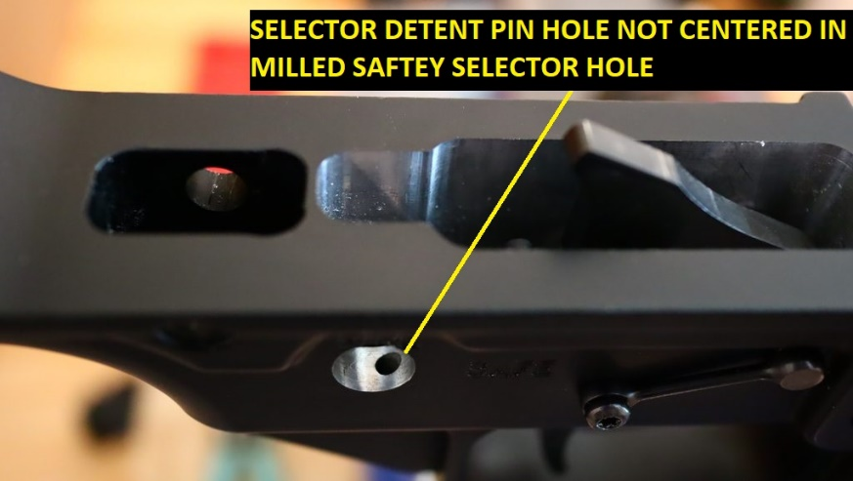
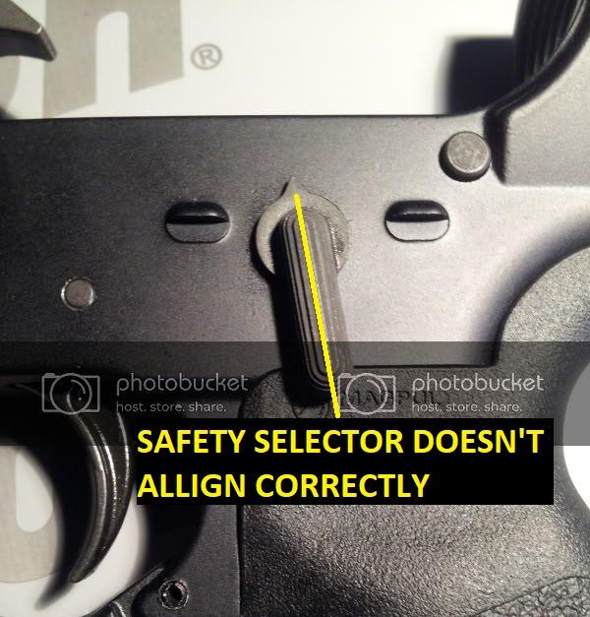
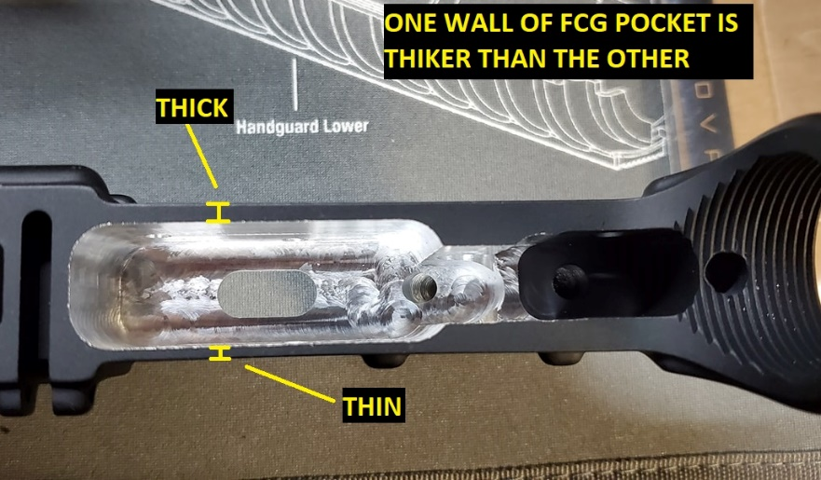
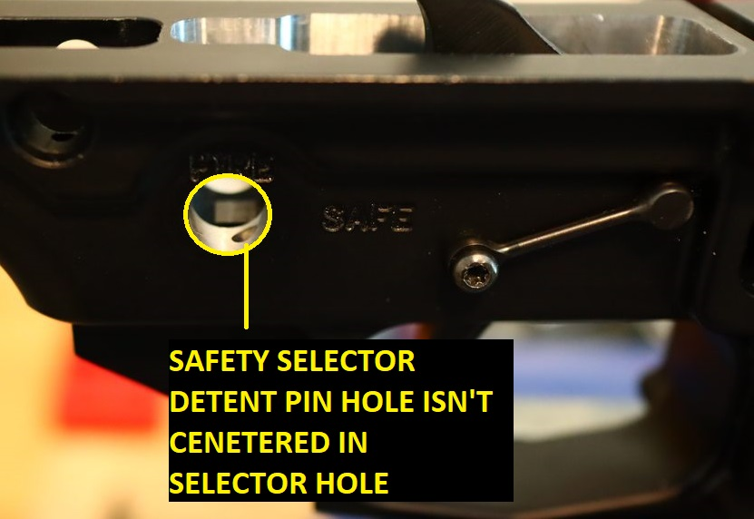

Step-by-Step Instructions:
Step 1: Turn on “Show file extensions”
(for MAC users see our website at www.GGD-Store.com to find a video showing how to do this on a MAC device)
This will allow us to change file extensions which is necessary since a .dd file is simply a .zip file with the file extension changed to .dd
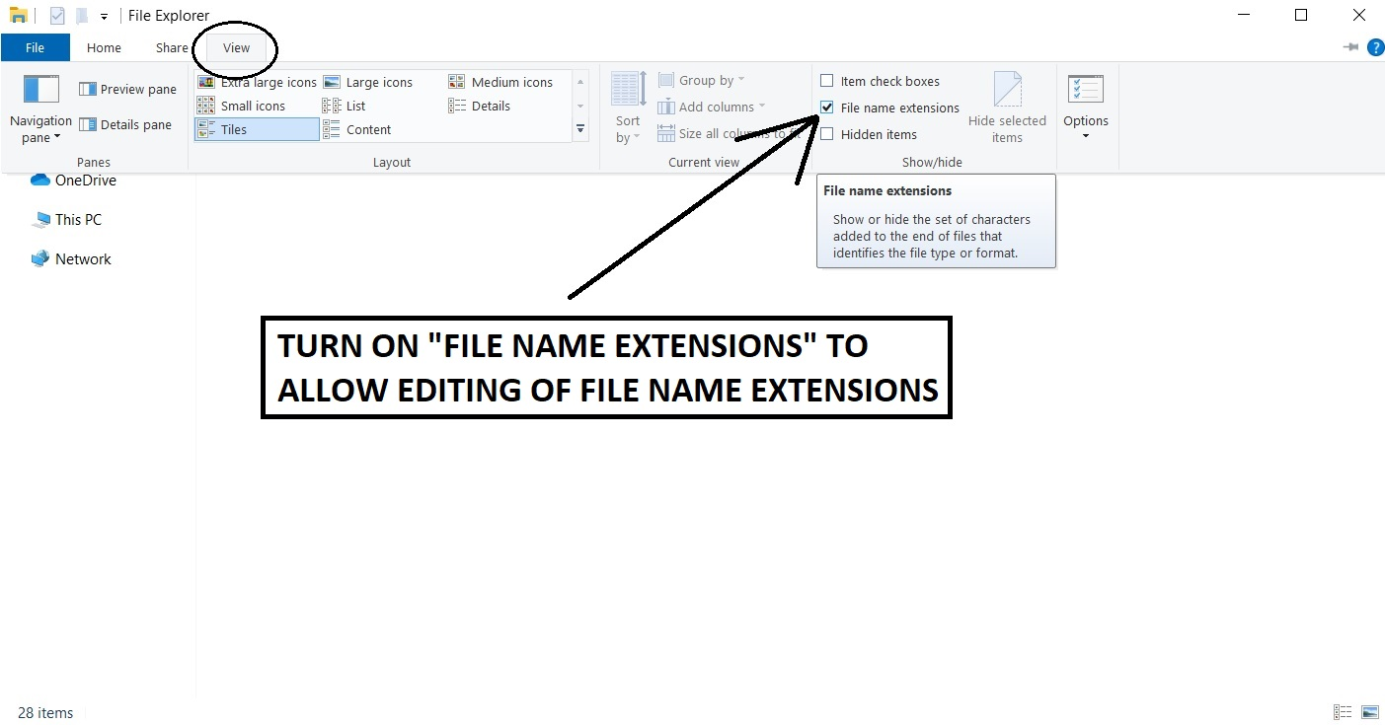

Step 2: Make a Copy of the File you wish to Adjust/Edit
This is so that you don’t accidently make changes to your original copy. We also recommend changing the name of your copied file so it won’t be confused with the original.
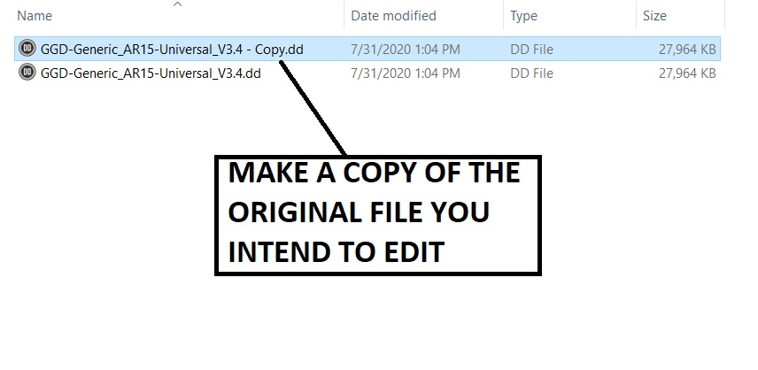

Step 3: Rename the .dd File to a .zip
You will simply right click the file and select “rename” and then delete the “.dd” at the end and replace it with “.zip”
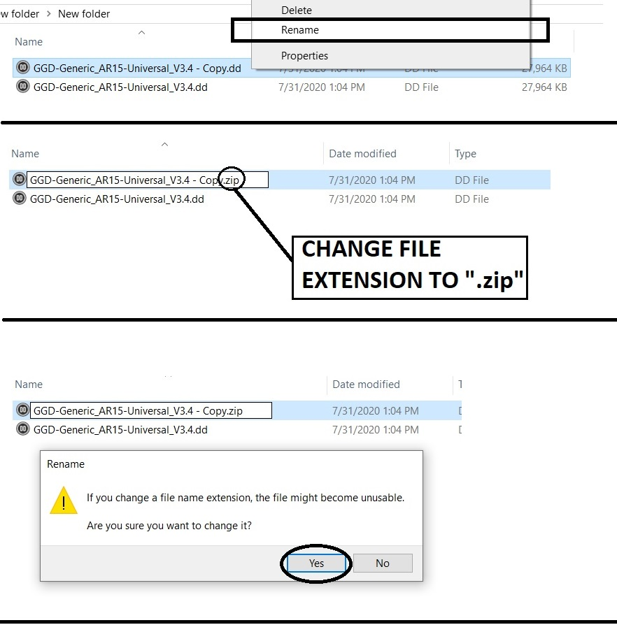

Step 4: Extract the files of the newly renamed .zip file
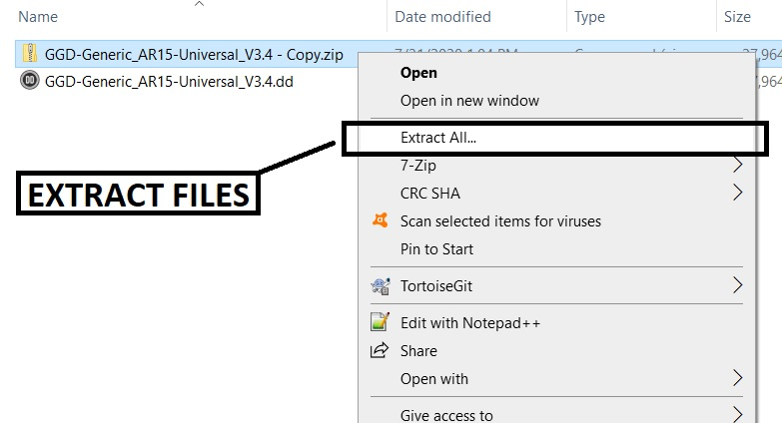

Step 5: Open the File
If you wish to adjust the fire control group pocket then you will edit the Op1 adjustments code and if you wish to adjust the selector and pin hole locations, edit the Op2 code
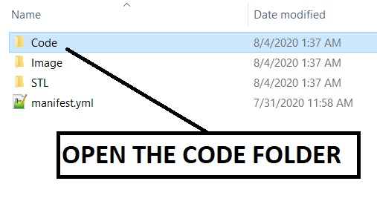

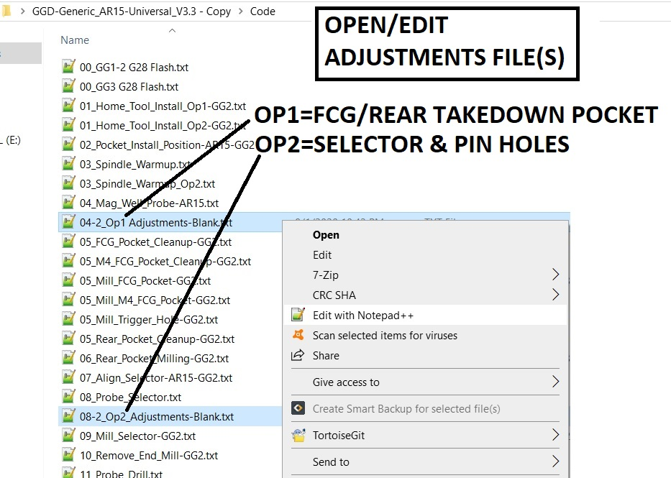
Step 6: Edit the File
Change the numeric value associated with the axis on which you wish to move the feature.
For example: If you want to move the selector and pin holes 0.5 millimeters forward you would reference the correct image from the Op2 reference images to determine that you would be adjusting the Y-axis value and in order to move it forward, for file versions 3.4 and newer, it would need to be a negative number.
So in order to move the selector and pin holes 0.5 millimeters forward you would change “Y0” to “Y-0.5”
Another important note is that when calculating the value to enter for the fire control group and rear takedown pocket (Op1) left/right adjustment to correct for a thicker/thinner wall you need to measure the thickness of each wall using calipers or another measuring device, find the difference between the two thicknesses, and then divide that difference by 2. This is because when you shift the pocket you’re not only adding that much thickness to the one side, you are subtracting that much thickness from the other.
So for a pocket which has a right wall that is 1.5 millimeters thick and 2 millimeters thick on the left wall performing the calculations would look like:
$Offset=\frac{{Thickness}_{LEFT} – {Thickness}_{RIGHT}}{2}$ → $2.0-1.5=0.5$ → $\frac{0.5}{2} =0.25$
Which means the pocket will need to move 0.25 millimeters to the right.
We would then reference the appropriate Op1 reference image and determine that we’ll need to adjust the X-axis value and that, for a file version 3.4 or newer, to move it to the right the value will need to be a positive value (even if your calculation came out negative)
So in order to move the FCG pocket 0.25 millimeters to the right you would change “X0” to “X0.25” in the Op2 adjustments code
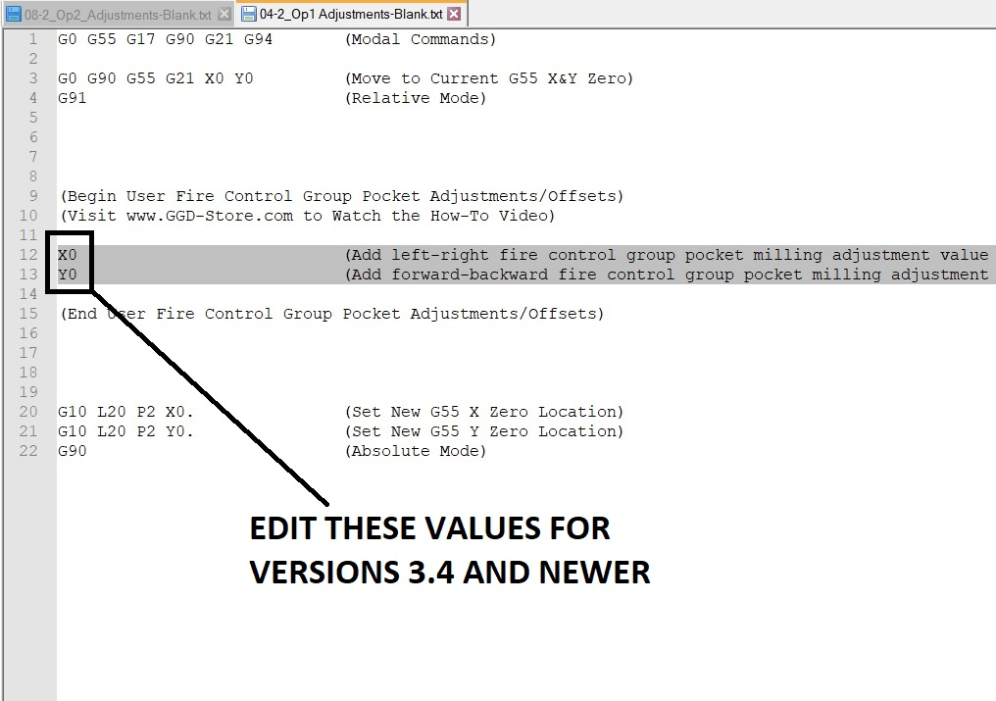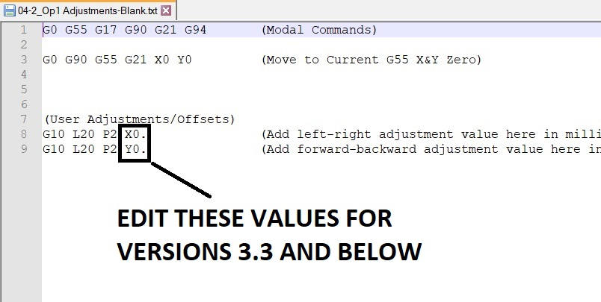

Reference for Op1 Adjustments:
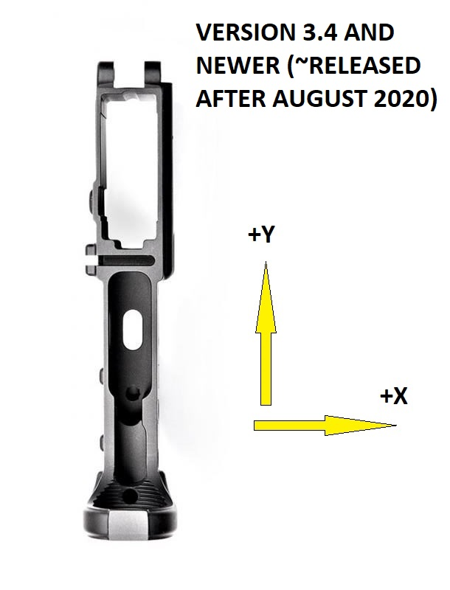
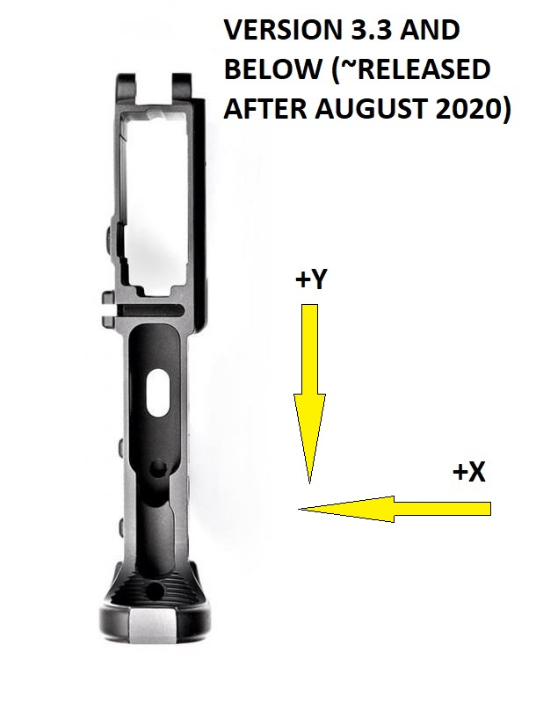
Op1 adjustments will move the fire control group pocket and rear takedown pocket. The diagrams below show which axis (X or Y) move the pocket in which directions. The direction of the arrow points to the direction the feature will be moved when using a positive value. A negative value will move the feature in the opposite direction than the arrow is facing for that given axis.

Reference for Op2 Adjustments:
Op2 adjustments will move the selector and pin holes. The diagrams below show which axis (X or Y) move the holes in which directions. The direction of the arrow points to the direction the feature will be moved when using a positive value. A negative value will move the feature in the opposite direction than the arrow is facing for that given axis.
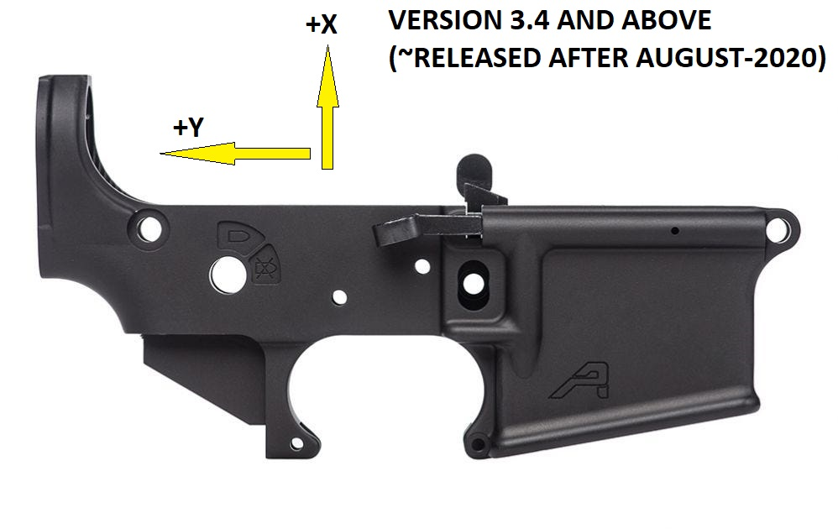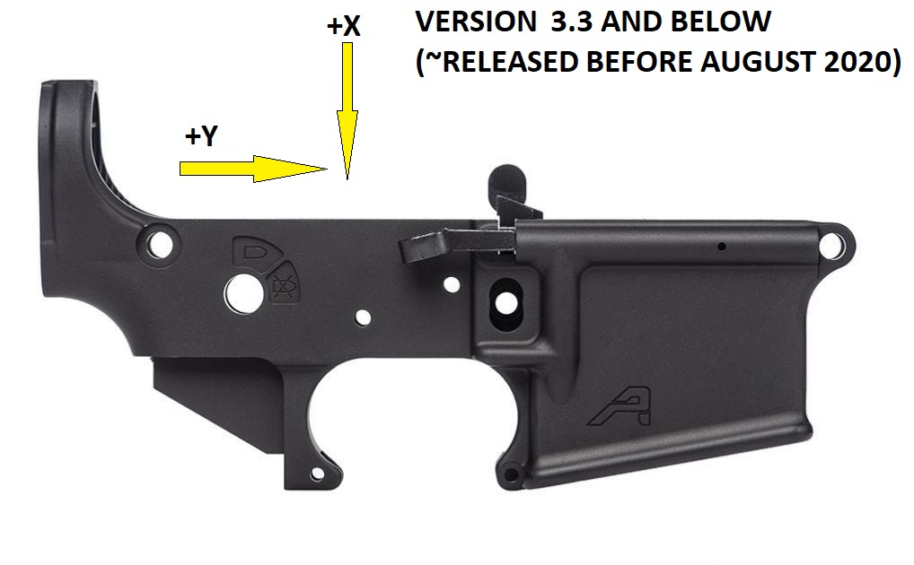
Step 7: Save your Changes
Save your changes

Step 8: Zip Things Up Again
Rezip your files back up making sure that the manifest.yml and other folders are in the root of the zip file (meaning don’t zip up the folder that contains all of these contents, select and zip them up directly as shown below)
Select all of the files and zip them up. On Windows this would be done by right clicking>Send to>Compressed (zipped) folder
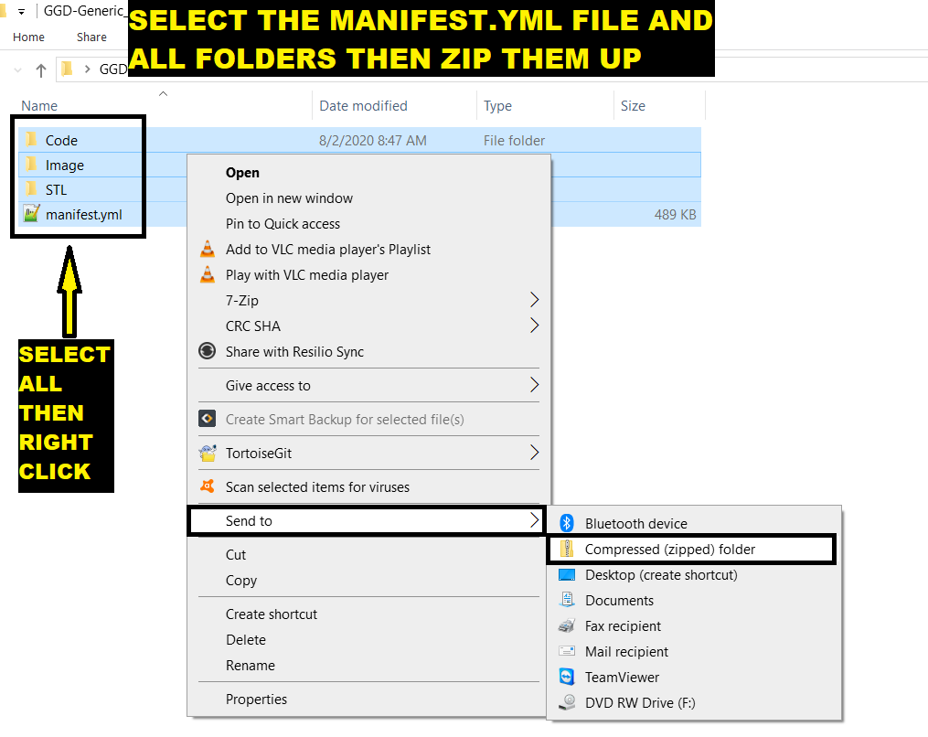
Step 9: Change it from a .zip File Back to a .dd File
Right click on the newly zipped file and rename it so that the file extension is a .d and not a .zip. Essentially just rename the file whatever you want, but be sure it ends with “.dd”
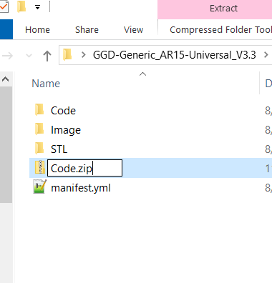

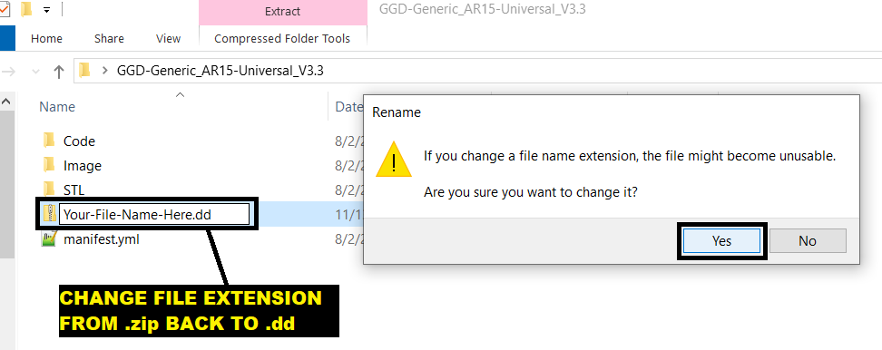
Step 10: Run your New File!
You should be able to run your new file just like you do any other .dd file!
