ENGRAVING ON THE GHOSTGUNNER
BEGINNERS GUIDE
(Please Please PLEASE read this before emailing/calling/texting/sexting/tweeting/twat-ing/ messaging/telegraphing/signal firing/ or anything-ing us)

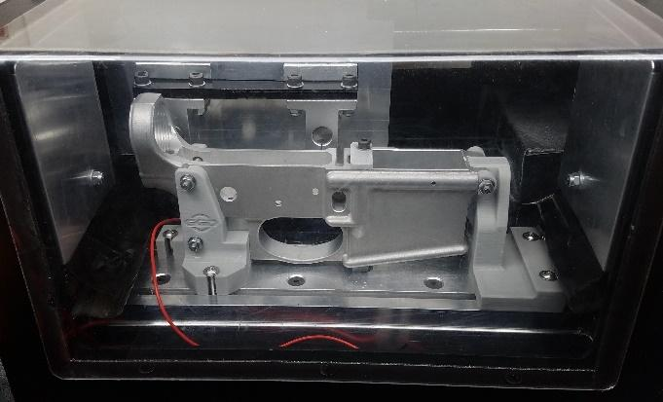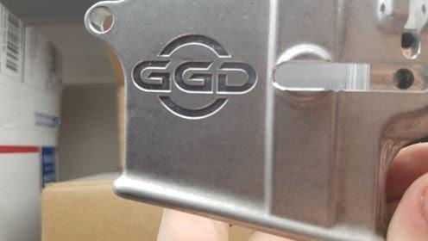
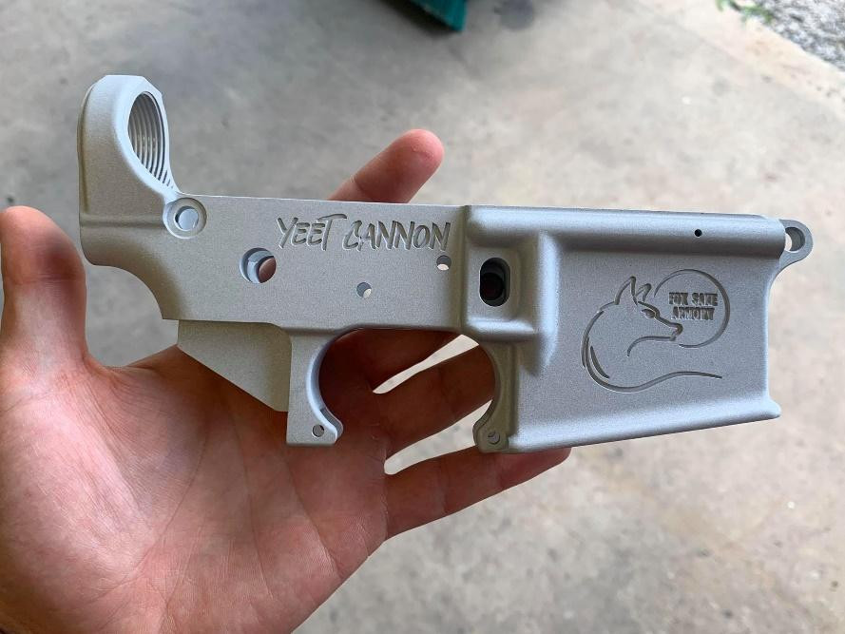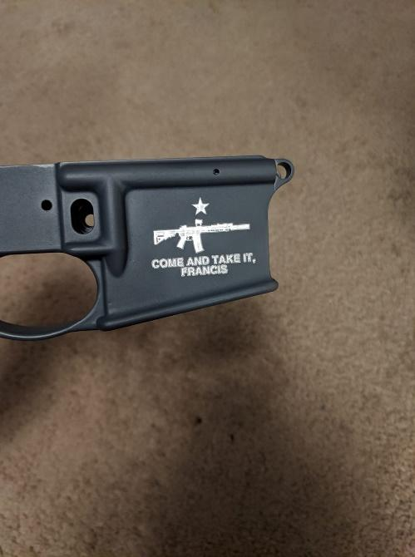

First let’s handle some FAQ’s:
- What all do I need to begin engraving?:
  - A Ghost Gunner (preferably a Ghost Gunner 2 as there may be some compatibility issues with GG1 due to having a smaller work envelope combined with the fact that the developers of Ghostwriter do not have access to a GG1)
  - At least one engraving bit (We sell and typically recommend to use what Ghostwriter was designed to use which is a 1/4” diameter shank, 2.5” overall length (OAL) Vbit with either a 30,45,60 or 90 degree tip. Ghostwriter has settings to potentially allow you to use a ball end mill or flat end mill, but these aren’t as well tested as the V-bits at this time)
  - A 1/4“ End Mill (The one that comes in the kit from DD and used for machining AR-15’s and AR-10’s is the one Ghostwriter is expecting you to use. GGD also sells end mill’s which work as well. This is used to probe the lower. Any 1/4” Diameter 3” OAL end mill should work)
  - An email account you don’t mind getting your engraving files sent to (Protonmail is a good choice if you are looking for a secure and free email service)
  - A computer that can access the internet (Some people have had success using their phones, but, ultimately, you’ll need to get your files onto a computer, anyways, to run the Ghost Gunner)
  - A lower to engrave (Not all lowers are suitable for engraving. You need your surfaces to be flat and nicely perpendicular to the spindle when engraving. Some manufacturers (Like Right to Bear Arms lowers) are known for having uneven surfaces that result in engravings that vary in depth across the engraving sometimes to the point of not making contact with the lower in some areas. We generally recommend Noreen Forged AR-15 lowers as a budget friendly option that generally works well for engraving)
  - A jig set to hold the lower during engraving: (Check out the jigs available at www.GGD-Store.com designed to be used with Ghostwriter on the Ghost Gunner. If you have access to a 3D printer you can also download the jig files from Ghostwriter or help support further development by buying the thumb drive from GGD that contains all of their files and codes)
- What angle bit should I buy?: Well that depends on what you primarily want to engrave. Typically, the smaller the angle of the bit the more capable of doing fine detail work it is. That being said, a smaller angle bit will wear out faster, be more prone to breakage, and need to go deeper to create the same width of cut as a larger angle bit would. A 45 degree bit is a solid all-around bit, but 60’s and 90’s are perfectly capable of engraving fairly detailed engravings in their own right.
- I ordered a thumb drive from a company that sells codes for the Ghost Gunner, but I can’t find where the engraving files are: While there are a couple places that sell (generally overpriced) predesigned engraving codes, the vast majority of the community wisely uses Ghostwriter to generate their own custom engraving files. You can generate a certain number of free files and past that you have to sign up to the Ghostwriter Patreon to get access to more. Essentially it works out to $1 per engraving file you generate. Once you create an engraving file, though, you can use it as many times as you want.

THE BASICS

Go to www.Ghostwriter.ServerRack.net

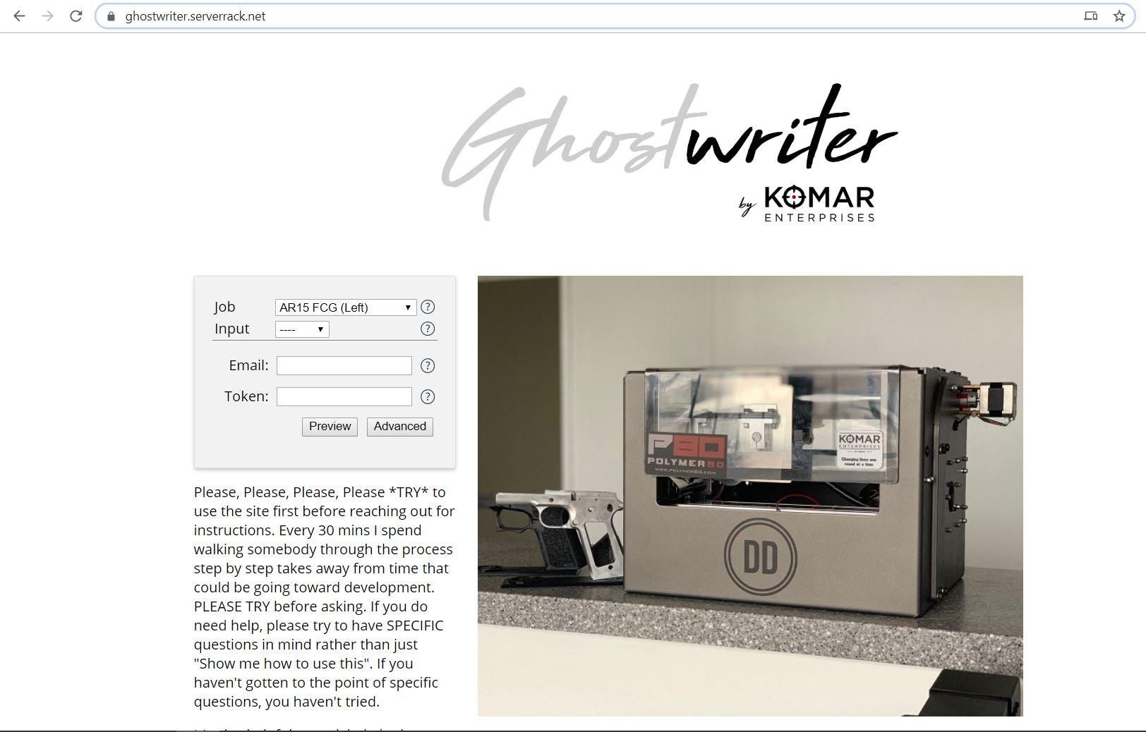

Select the job type that best fits what you are attempting to do
This should make sense to you. If you want to engrave on an AR-15 and the spot you want to engrave is on the right side magwell, then select AR-15 Mag Well (Right)

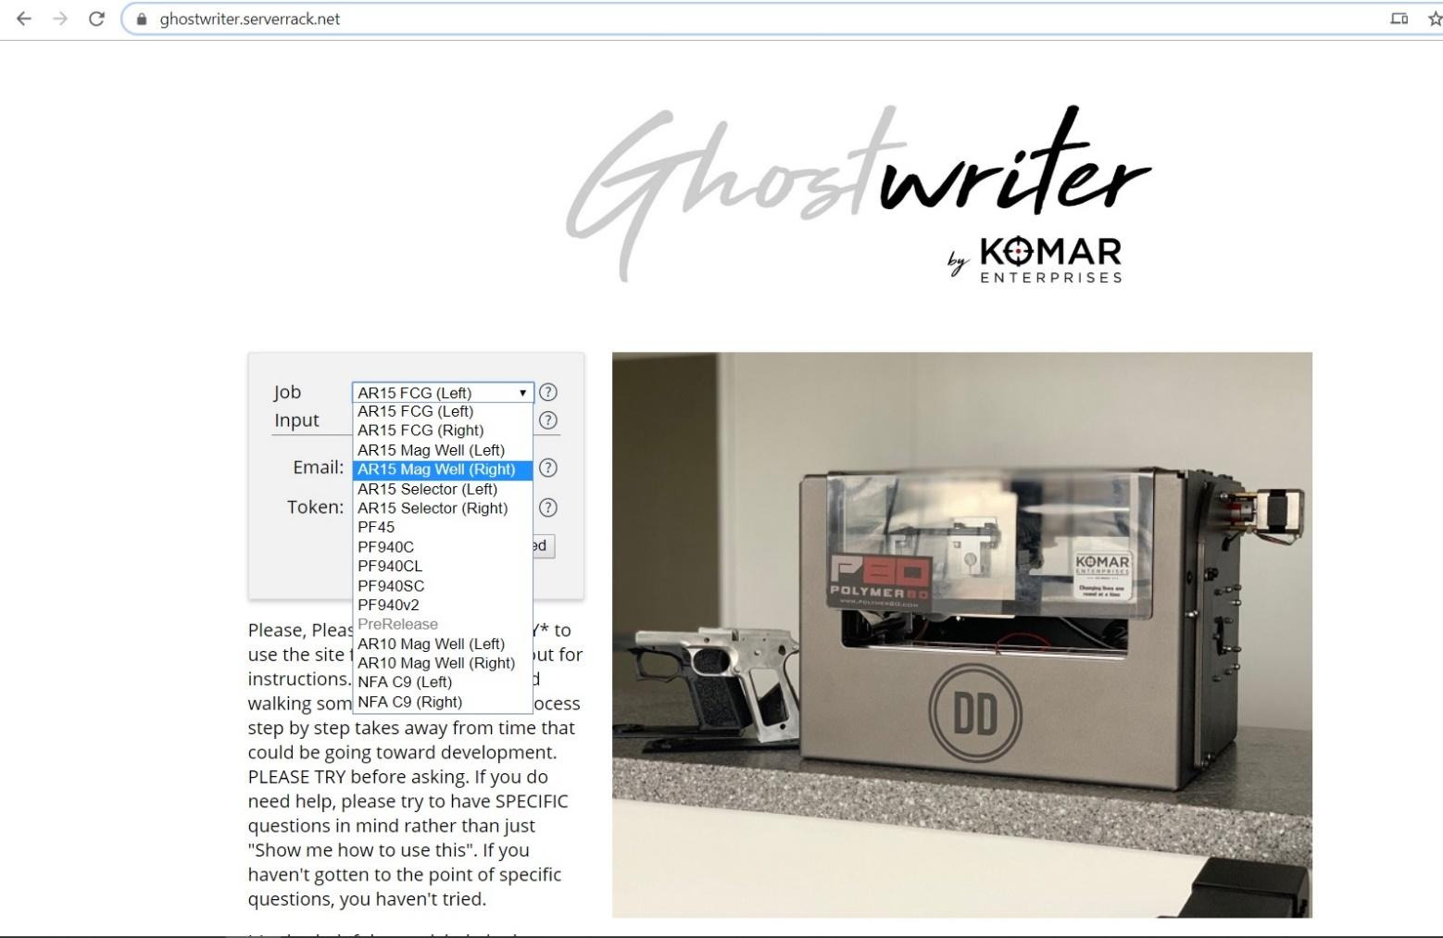

Decide if you want to engrave an image or just text
If you would like to have both an image and text you can add the text to the image using Microsoft Paint or some other image editor. Alternatively, you can do the text and image as separate jobs.
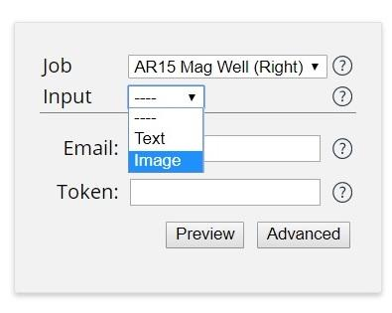

Either enter your text or upload your image
(For more on best practices with image choices for Ghostwriter you can view the more in-depth portion of this document)
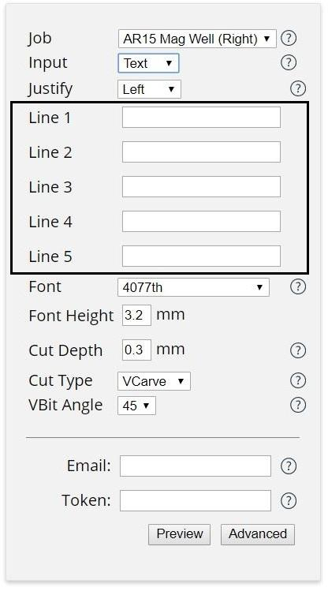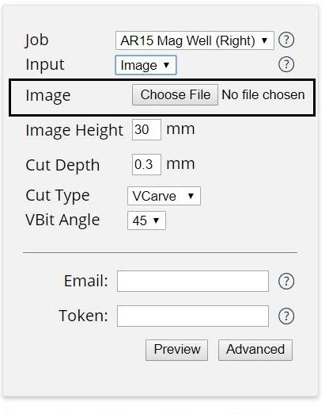
Set your “V-Bit Angle” (If you’re using one that is)
This is simply the angle of the tip of the engraving bit you are using. You should know this from either what is labeled on the side of the bit itself or the packaging your bit came in. Currently the options are 30,45,60,and 90.
It is VERY important that this angle match that of the engraving bit you will use to do the actual engraving. If it does not match then your engraving will not match what was shown in the preview.

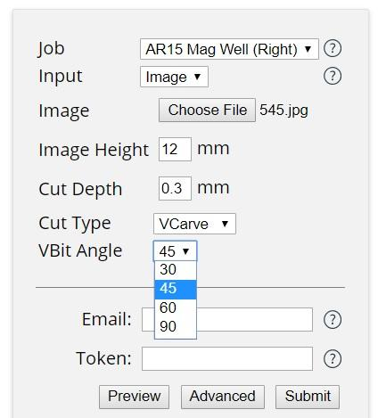

Before changing settings get an idea of what it will look like with the current settings by generating a preview image

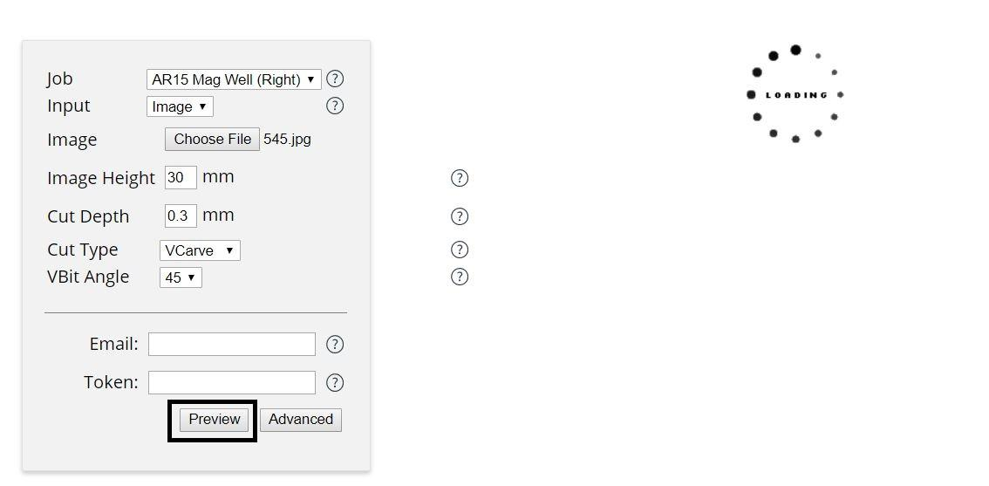

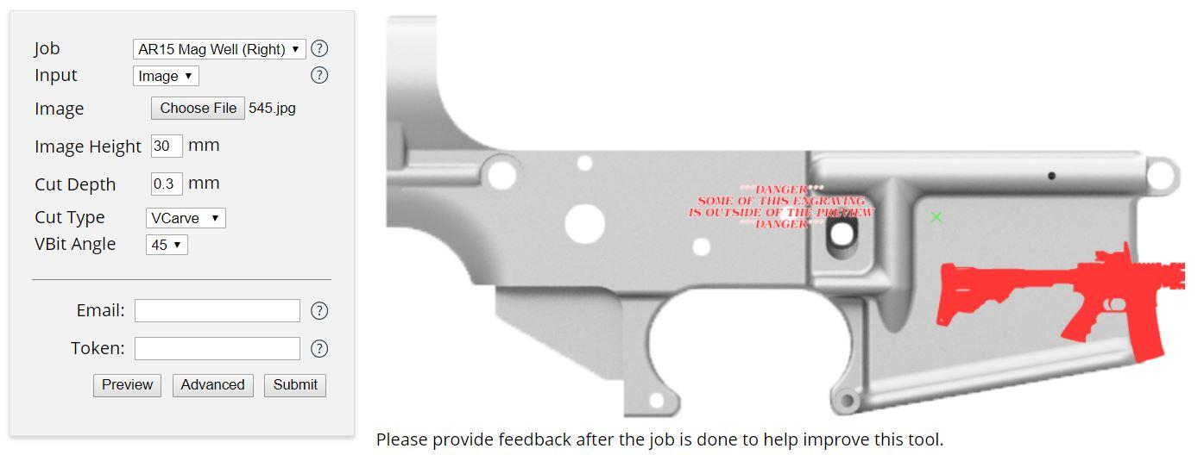

Adjust the Scale of your Image or text using “Image Height” for images and “Font Height” for text
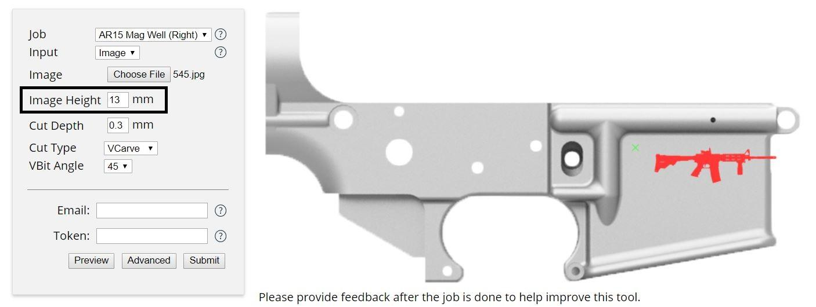
Now Open the “Advanced” Tab and make adjustments to the “X Offset” and Y Offset” fields to move the engraving to the location of your choice.
The X offset will move things up and down (Positive moves things up) and Y offset will move things left and right (Positive values move things to the right)
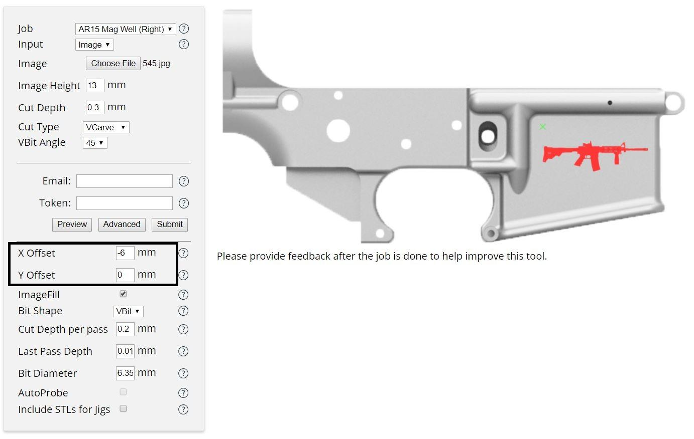

Adjust additional values
We recommend that for those that don’t understand the various additional settings to simply leave them at their default values. If you would like to understand the various settings to feel more comfortable changing these settings then please refer to the latter portion of this guide that goes into more detail.

Enter your email address
This is the way that you will receive your engraving file. If you don’t feel like using your personal email account you can always make a new email account for this purpose. We recommend Protonmail for privacy.
When you are happy with the way that the preview image looks and your other settings go ahead and submit your job
Make sure you are certain that your preview image appears EXACTLY as you want your engraving to turn out. If there are any stray lines or missing features do not assume that these will magically appear or disappear when it comes time to run the code. The preview image is directly calculated from the generated gcode produced by Ghostwriter.
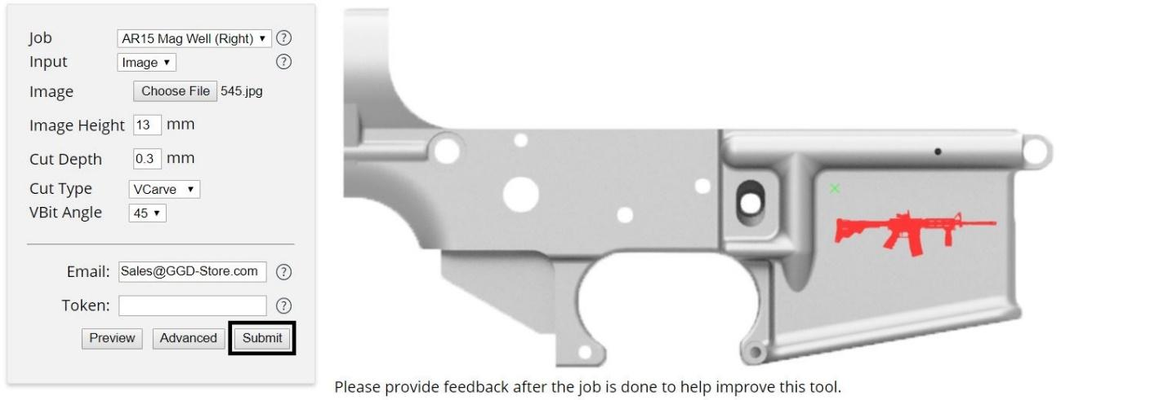

Help support Ghostwriter and get early and exclusive access to features as well as an additional number of engravings per month by becoming a Patron on Patreon https://www.patreon.com/mkomar/posts
Ghostwriter is essentially a free-mium service where you can access the majority of the core functionality and generate codes for free a certain number of times before you will need to sign up to get access to more. It comes out to roughly $1 per engraving which is an insane value for what you are getting and is essential to making future updates and content possible.
Originally Ghostwriter operated on a completely optional donation system, but nearly NOBODY donated despite thousands of users having used the site to generate files. Hosting the site was literally costing the creator money and unless something was done he was likely to decide to no longer support the project if there was no community support to keep things going.
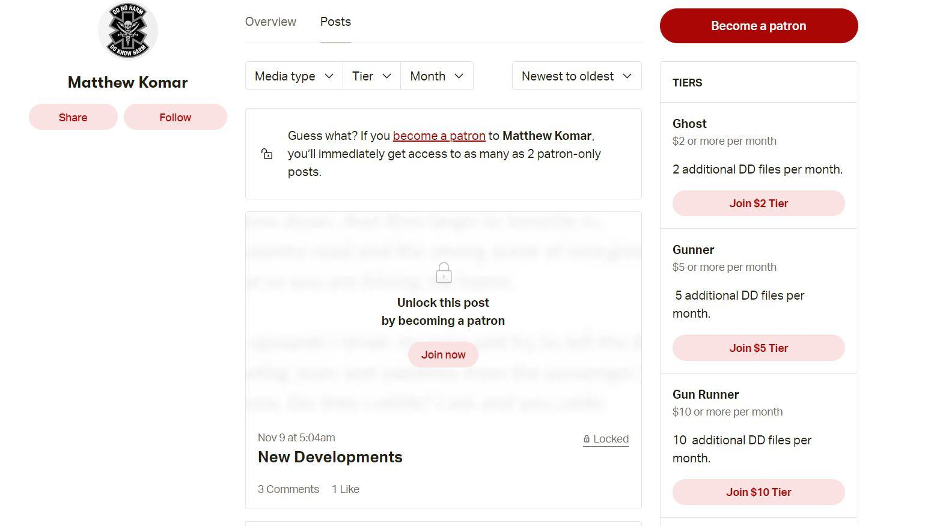

ADVANCED USER GUIDE

Tip on selecting images
Selecting the right image is very important for a successful engraving using Ghostwriter. While you can upload just about any photo the actual end result of the engraving will likely not be to your satisfaction unless the preview image (More on that later) looks EXACTLY how you wish your engraving to look.
Here are some guidelines on selecting images so that you can hopefully get the results you desire:

Choose an image with a high amount of contrast between what you want to be engraved and the rest of the image
Ghostwriter has to analyze the photo for what it detects as the main features of the image to then choose that to engrave. The more amount of contrast the more likely Ghostwriter will correctly identify what it is you want to be engraved.
(Below: Image and resulting engraving preview of a photo with poor contrast)
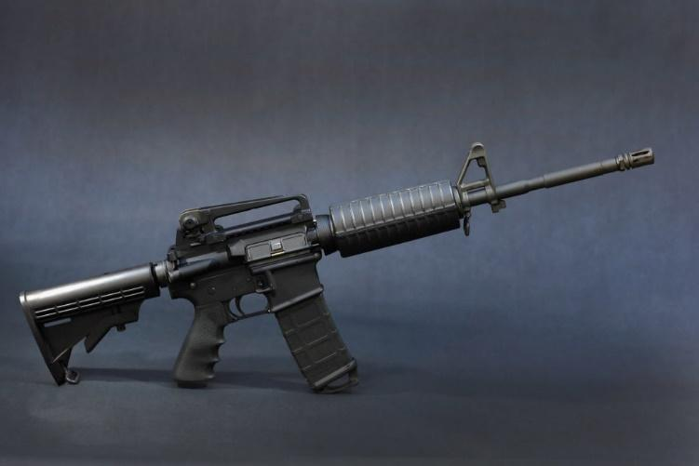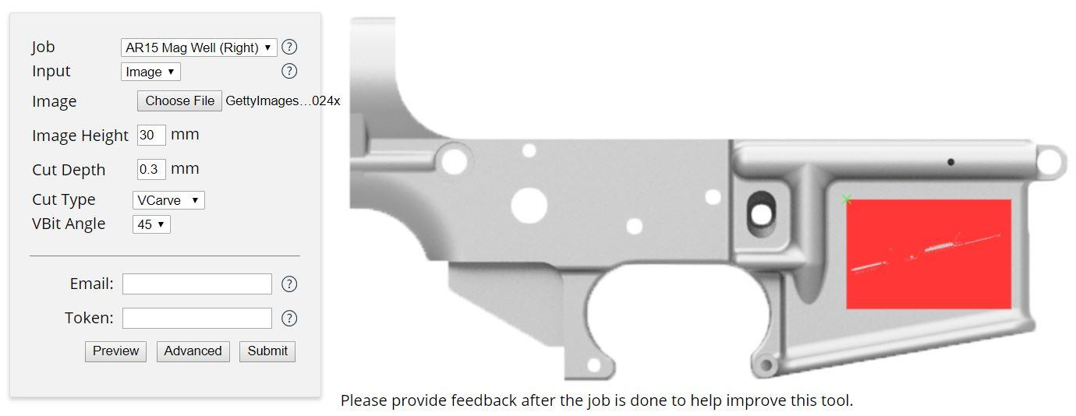
(Below: An example of an image with good contrast and resulting preview) 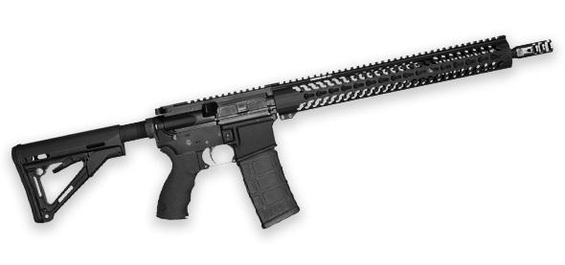
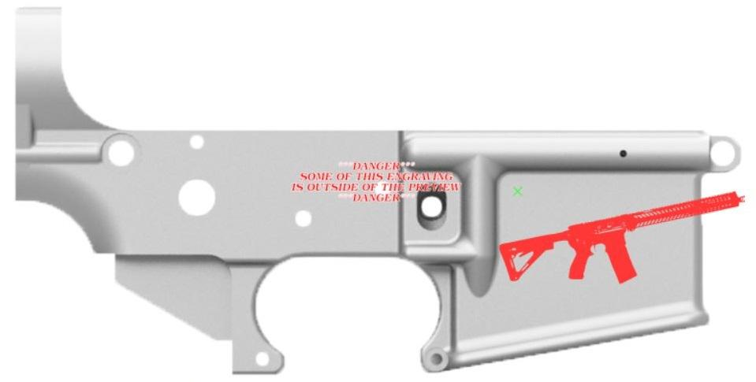

Be careful of images with a transparent background:
The images below may LOOK the same, but one has a transparent background and the other has a solid white background
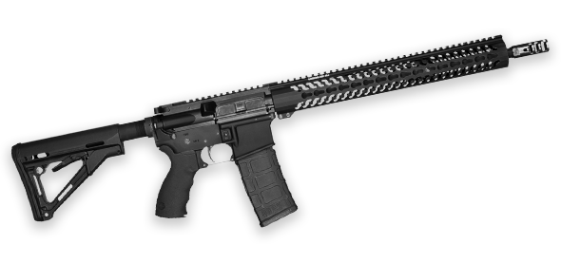

But upon closer inspection when viewed in Photoshop you can see that they are different
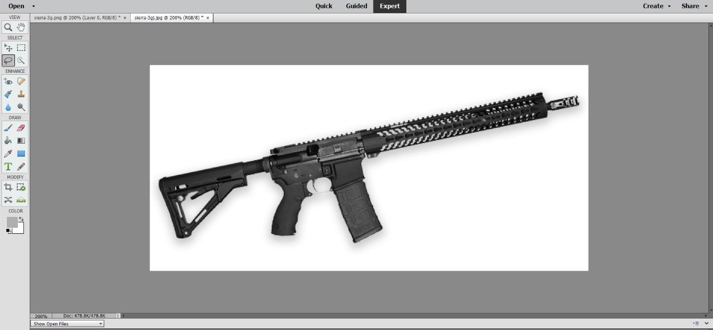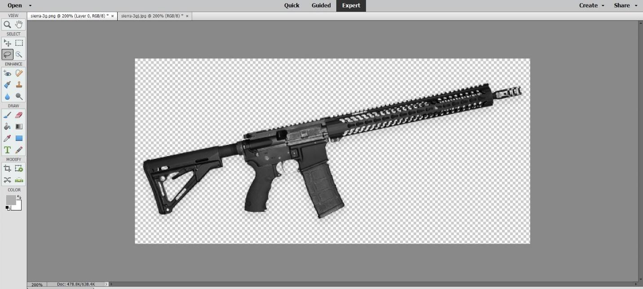

And here is how the image preview turns out when using the image with the transparent background
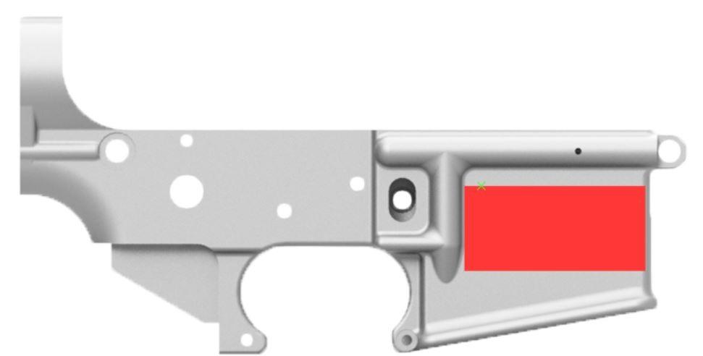

The easiest way to get rid of the transparency is to resave the image as a .jpg since this file format doesn’t support transparency.

The best images to try to find or use are silhouettes
Silhouettes are simply block images in black on a pure white background. This is by far the best type of picture to use with ghostwriter as not only will it make it very easy for Ghostwriter to pick out the features, but since there is no way to have color gradients when engraving the style of image should be able to be matched nearly identically to what will be engraved.
(Below: An Example of a Silhouette image)
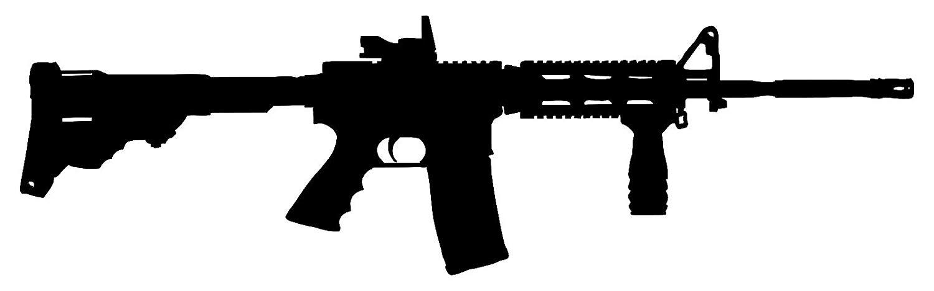

Invert colors if you want to swap what part of the image is engraved and which parts are not
The preview image shown is indicating what portions will be cut/engraved. If you would prefer to have that reversed the easiest solution is to invert the colors of the image you are using with a program like Microsoft Paint
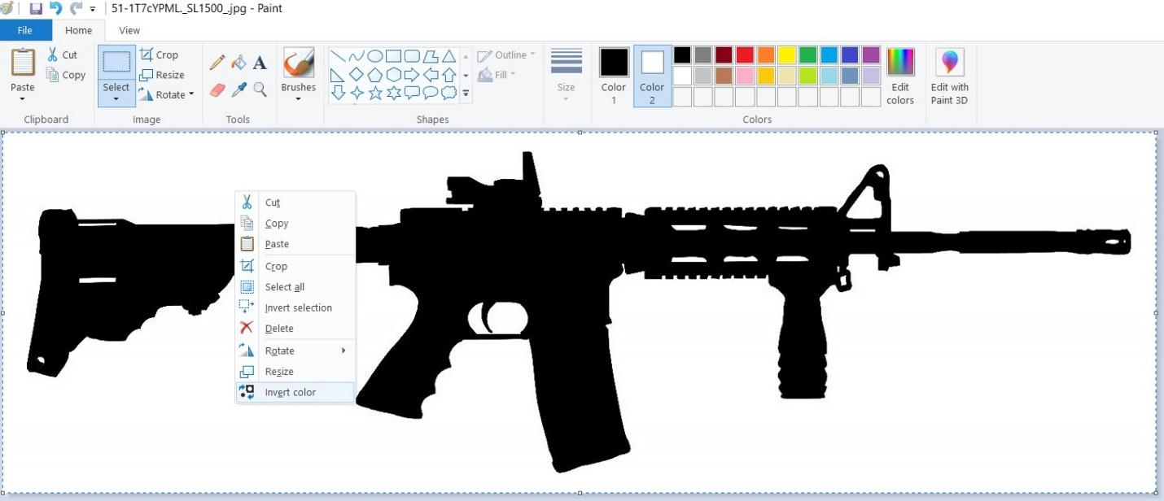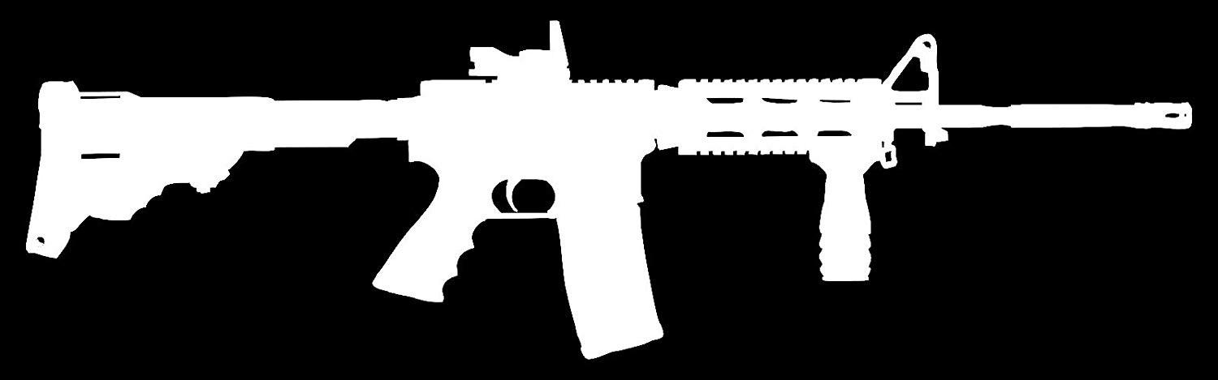
(Below: Example of the effect inverting the colors in a photo has on a Ghostwriter engraving)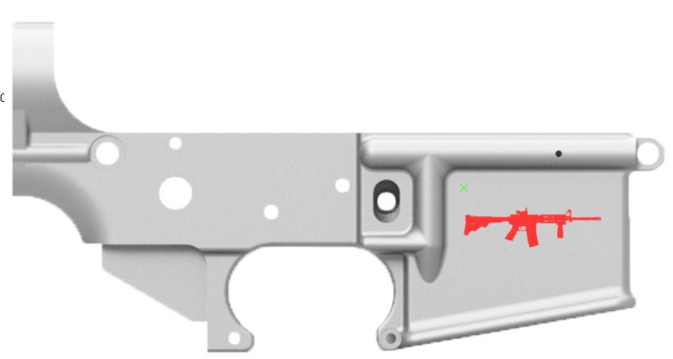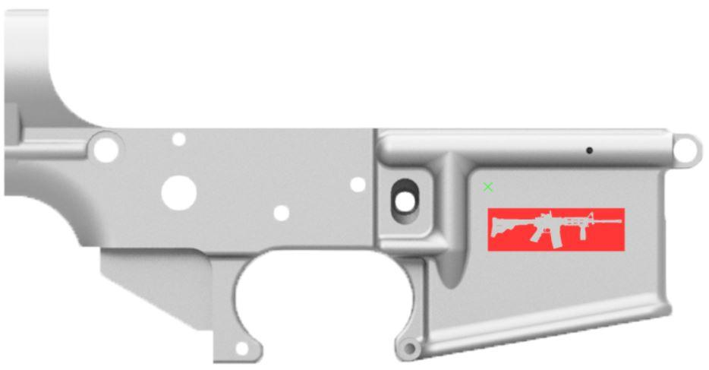

ADVANCE SETTINGS EXPLANATIONS

Cut Depth: This is the maximum cut depth for the engraving.
In V-Carve mode this value is the limit for how deep the cutter can go below the surface to be engraved, however this does not guarantee it will actually ever get this deep. V-carve is smart and will not go deeper if, past that depth, it would create a line width that would make a cut that went outside the bounds of what you were trying to engrave (think about it as if your engraving is a coloring book and V-Carve won’t generate code that colors outside the lines). Another note is that unlike Trace Mode V-Carve changes its depth constantly, as needed. This allows it to generate sharp corners despite using a rounded/conical/spherical bit.
In “Tracing” mode this directly sets how deep the tip of the cutter will go below the surface of the area to be engraved. If you type “100” into this field in tracing mode the code generated will attempt to actually make this happen regardless of how bad of an idea that is or how bad the resulting image would be. Tracing mode is unintelligent and will simply go to the depth you set and trace out the outlines of the text/image you set. In Trace Mode the value entered into this field directly correlates to the width of the line it cuts. For Ball End Mills and V-Bits the calculations for the correlation between the width of cut and depth of cut are as follows:
V-Bits:
$$W=2⋅h⋅Tan(θ⋅0.0087266)$$
$$h=\frac{W}{2⋅Tan(θ⋅0.0087266)}$$
Ball End Mills:
$$W=\sqrt{4⋅\left(-h^{2}+d⋅h\right)} \\ h=\frac{d±\sqrt{d^{2}-W^{2}}}{2}$$
Where:
$W$= Line Width,$h$= Depth of the cut, $θ$= Angle of the bit (in degrees), $d$ = diameter of the end mill
Cut Type: There are 2 cut types/modes: Trace (Top) and V-Carve (Bottom). The simplest way to think of it is that Trace mode is dumb and V-Carve is smart. Notice the sharp corners on the V-Carve preview compared to the Trace preview. Also the most prevalent difference is Trace Mode’s tendency to bleed over as seen in the preview image. There are instances, however, where the user may explicitly desire Trace Mode so we have allowed users to have it as an option. Generally, though, you should be using V-Carve unless you have a specific reason not to.
V-CARVE ↓ ↑ TRACE MODE
Trace: Notice that on the Trace mode preview has features that are bleeding into each other that are definitely not meant to as seen when comparing it to the source image due to it engraving outside the lines. This is because all Trace mode is doing is exactly that, tracing. Think of using a thick tip highlighter and tracing directly over the thin outline of an image or text. If your highlighter is centered on the center of the line then you will have some of the highlighter outside of the line and some on the inside of the line. Ideally if we were coloring in a coloring book we would want to only color INSIDE of the lines. This effect is exaggerated the deeper you set your cut depth when using V-Bits or Ball End Mills. In Trace Mode the Max Cut depth is fixed at the depth set by the user
V-Carve: This is the mode you should be using unless you have a reason not to. V-Carve will dynamically adjust height as well as inset itself from the edges of the engraving to ensure that what is engraved will match what you input. This also means that despite what you put for max cut depth, V-Carve won’t go deeper if it would cause the engraving to be blown out in that location because of it.

Imagefill: Without this option enabled Ghostwriter will only attempt to engrave an outline (Left) of your text or uploaded image, however when this option is enabled (Right) it will also engrave away the rest of the image or text as well. Be aware that this takes a substantially longer time especially when using a V-bit or Ball End Mill, but especially a V-Bit due to its fine point being ill-suited to clearing away much material at a time thus requiring a small step-over
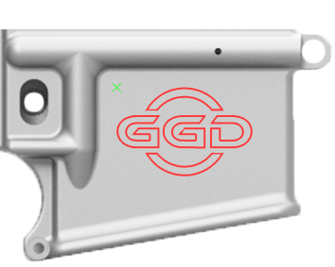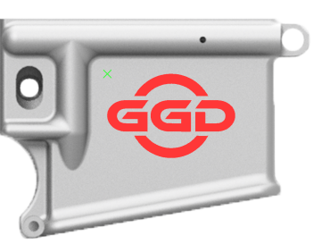

Image Height: This determines the maximum height of your image. If you want your image scaled up bigger (Left) use a larger number and if you want a smaller scaled image (Right) use a smaller number.
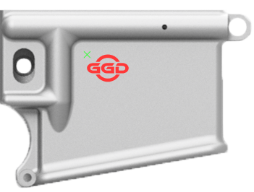

Font Height: This is the maximum height of the largest single character in the current font type you are using. For a larger font (Left) increase this value, for a smaller font (Right), reduce this value.
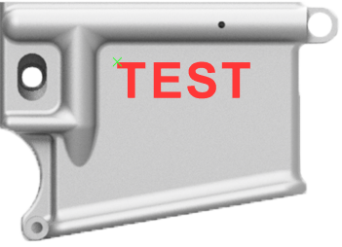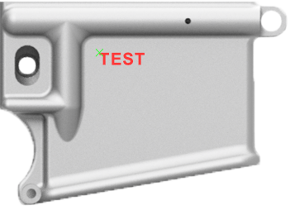

Justify: Justification lines up the Left, Right or Center of multiple lines of text. This option has no effect on a single line of text.
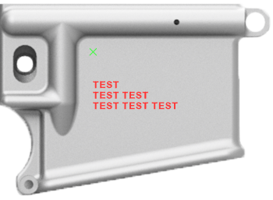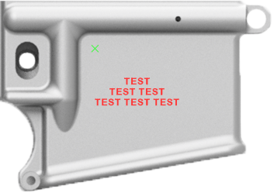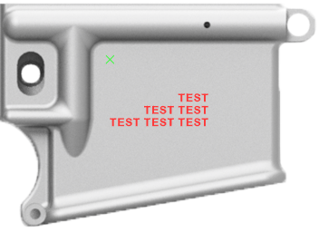

V-Bit Angle: The angle of the V-shaped bit you are using if you are, indeed, using a V-shaped bit. Common angles are 30, 45, 60 and 90. Make SURE that this angle matches what you intend to use when you engrave your project. You will be reminded in the file which angle you have set so make sure that you insert the same angle as the steps indicate that you had selected for that job. Failing to do so will result in a different looking image than what was shown in the preview, generally meaning undesirable results. A larger angle V-bit means that it is more robust and likely to last longer, but also that it is less forgiving on uneven surfaces since the line width it engraves changes more for the same given change in depth. A smaller V-Bit angle is generally better for detail work, but is more prone to breakage and premature wear. Keep in mind that if you are using Trace Mode that the angle of the V-Bit will determine how wide of a line it is tracing out at the set depth.
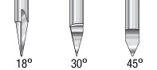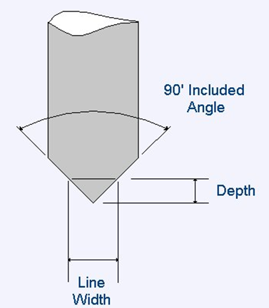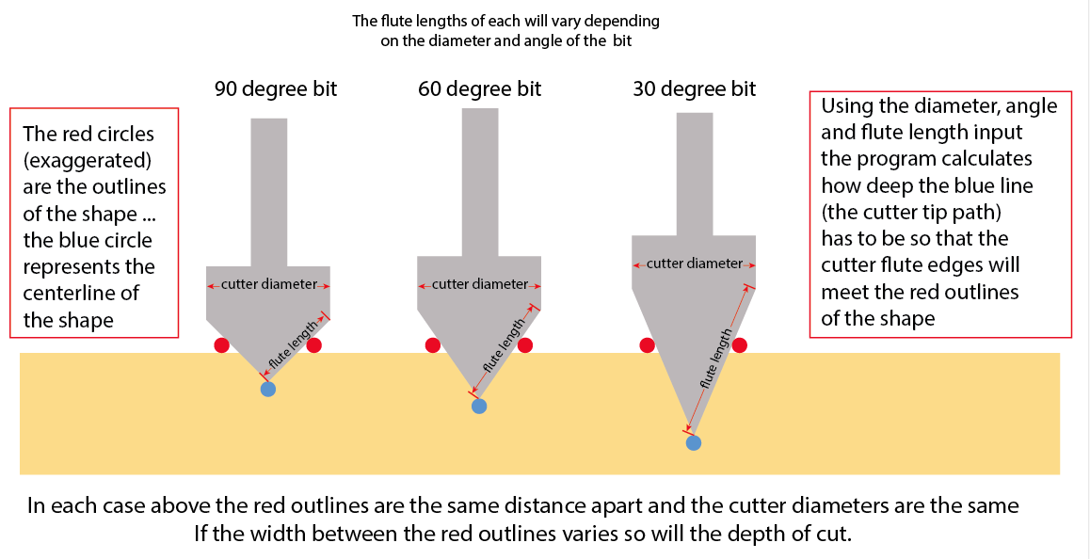

X Offset: Move the image or text up and down to place it where you want it to ultimately be engraved on your workpiece. A Positive value will move your engraving up and a negative value will move them down. This is an absolute value so if you move it up 1mm and you determine that it needs to come up another 1mm then you would enter the value “2”.
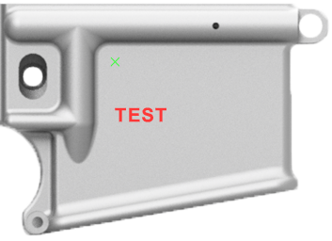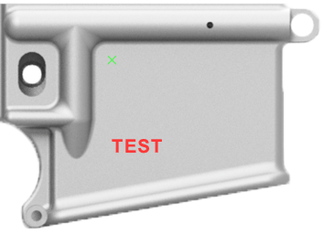

Y Offset: Move the image or text left and right to place it where you want it to ultimately be engraved on your workpiece. A positive value will move your engraving to the right and a negative value will move it to the left. This is an absolute value so if you move it to the right 1mm and you determine that it needs move to the right another 1mm then you would enter the value “2”.
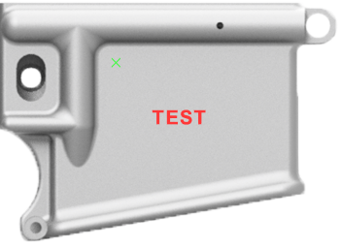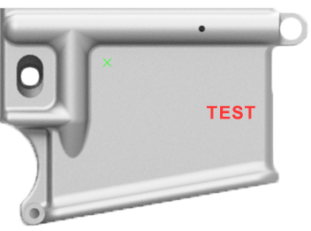
Rotation: Rotation of the text or image from horizontal, in degrees. A positive value will rotate it clockwise and a negative value rotates it counter-clockwise.
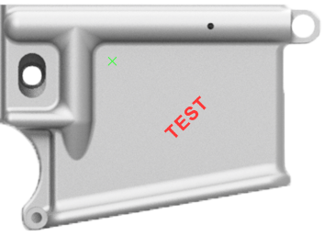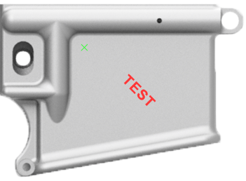

Bit Shape: The options are currently: V-Bit (Left), Flat End Mill (Center) and Ball End Mill (Right). The image shown depicts tools meant for wood carving, but the bit shapes match their counterparts used for milling aluminum.
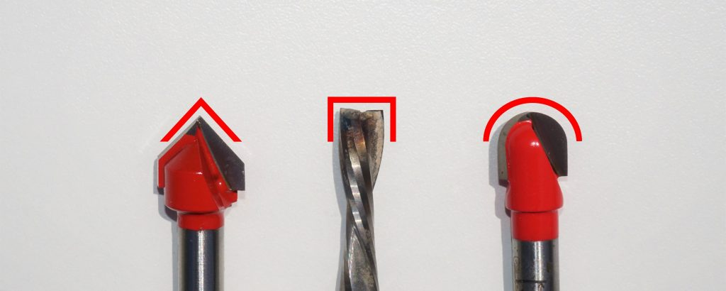
V-Bit: Most common type of engraving bit used on the Ghost Gunner, currently. V-bits are more forgiving on surfaces that are uneven or aren’t perfectly perpendicular to the spindle. This is because the width of cut does not increase as much for a given change in height/depth compared to a ball end mill. There are also several drawbacks including the possibility of rounding off or breaking a tip and the fact that, due to the tool coming to a fine point, it is not well suited to clearing out large areas of material which means, in order to get a good surface quality when doing imagefill, a small stepover must be used resulting in greatly increased engraving times compared to the other types of engraving tools.
V-Bits come in a variety of angles with the most common being 30, 45, 60, and 90-degree bits
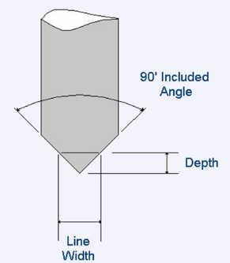
Flat End Mill: Good for clearing large areas, but not great for any fine or even moderate details.
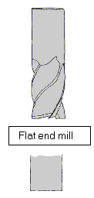
Ball End Mill: A compromise between V-Bits strength in detail work and the ability to much more quickly clear larger areas yet has much more durability and no tip to break or wear out. Also allows for much shorter cleanup pass times. Ball end mills aren’t as forgiving in fine detail work or with surfaces that are not even or perpendicular to the spindle.
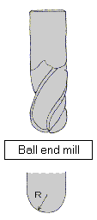
Cut Depth per Pass: Ghostwriter engraves in passes at progressively deeper depths. The Cut Depth per Pass setting determines how far down it steps after each layer is complete.
Large Cut Depth per Pass settings will have more of the tool engaged and produce more side load, but will also spread the wear to a larger section of the tool thus prolonging tool life so long as sufficiently matched feed rates are used. Too fast with a deeper depth per pass will cause the tip to break, the spindle to bog down, poor cut quality etc.
For the second to last pass, however, it will move down to a depth that is equal to Cut Depth-Last Pass Depth and then the final pass will only go down by the amount set in Last Pass Depth Setting.
Last Pass Depth: The Pass Depth is the amount (depth) of material that will be left for the final pass of cutting. Ghostwriter is set up to engrave in multiple passes/depths until finally reaching the Cut Depth set by the user. Ghostwriter will always leave the Finish Pass Stock to be removed during the final pass even if your Max Depth per Pass is set to a value deeper than the max depth of cut for a given design.

If your settings are:
Last Pass Depth =.03
Max Depth per Pass = .1
Cut Depth= 0.5

And your max depth at a location in the design is .5 the the cut depths for the passes at that location in the design will be.
pass 1: .1
pass 2: .2
pass 3: .3
pass 4: .4
pass 5: .47
pass 6: .5 (this is the finish pass. .5-.47=.03)

AutoProbe: This option should generally not be used. It was originally invented as a workaround to issues with uneven surfaces however there is a decent likelihood that, when using this feature, there is an issue with the probe while you aren’t present and could ruin your work piece/engraving.
AutoProbe essentially just reprobes every so often (it is actually based upon X-Y distance from previous probe location) in order to reestablish the surface height at that location. The issue is that engraving produces aluminum dust and burs and the probing feature on the GG doesn’t know the difference between contacting this vs contacting the surface of the work piece. Also if it doesn’t sense a probe, for whatever reason, it will continue to drive itself down into the surface until it either bogs down, breaks the bit, or mills all the way through the work piece.

Include STLs for Jigs: This will include the .stl files for printing out your own jigs if you have a 3D printer and desire to do so. In order to access the .stl files included with your .dd file you would simply run the file and, when prompted, download the .stl files at the beginning of the job.

Line Spacing: The vertical spacing between lines of text. This is a multiple of the text height previously input. A vertical spacing of 1.0 could result in consecutive lines of text touching each other if the maximum height character is directly below a character that extends the lowest (like a "g"). A higher value in this field will increase the space between lines and a lower value will reduce them.
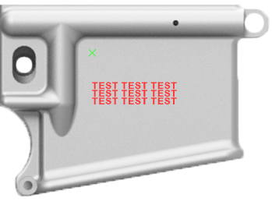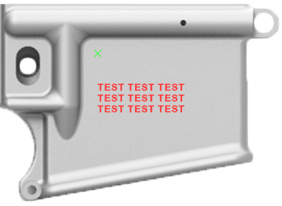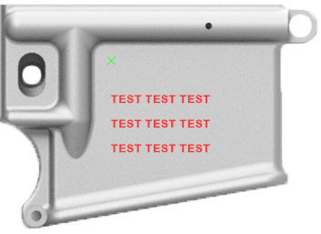
Char Spacing: Ghostwriter uses constant character spacing. This value is the space between characters (letters) expressed as a percentage of the maximum width of the characters in the currently selected font. This value can’t be 0 so if you would like no space between characters simply enter something extremely small like 0.1
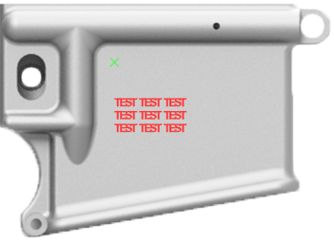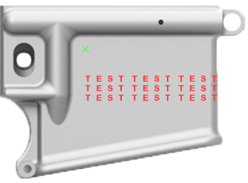
Word Spacing: The space between word or the width of the space character. This is determined as a percentage of the maximum width of the characters in the currently selected font
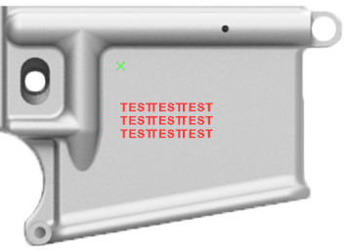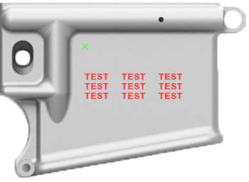
Feed Rate: The speed at which the spindle will move in the X and Y axis’. Increasing this speed will shorten engraving times, however if pushed too far may produce less desirable cut quality, premature tool wear, and potentially snapping the tip of V-Bits. Too slow of a feed rate will also cause premature tool wear as well in addition to increased engraving times.
Plunge Rate: The speed at which the spindle will move down into the material when changing depth.

Token: If you have one (Which normally you won’t) enter it here. A token is a code that allows someone to generate an engraving file without having to be subscribed on Patreon or use one of the free credits a new user gets.

Bit Diameter: Diameter of the engraving bit. For a V-Bit that would be the widest part of the cutting profile, for a Ball End Mill it would be the diameter of the ball, and for a Flat End Mill it would be the cutting diameter of the end mill.

Text/Image Width Scaling: The width, in percentage, that you would like to scale your characters/letters or image. When 100 is selected the width of the character is not scaled. Value other than 100 will result in the character width scaled by the percentage specified. (i.e. Circles will become ovals)

Mirror Text/Image: Mirror the text or image about a vertical axis (This is the same as Flip Text except is it about the vertical axis)

Flip Text/Image: Flip the text or image about a horizontal axis. (This is the same as Mirror Text except is it about the horizontal axis)

Circle Radius: The circle radius is the radius of the circle that the text in the input box is placed on. If the circle radius is set to 0.0 the text is not placed on a circle.

Outside Circle: Select whether the text is placed so that is falls on the inside of the circle radius or the outside of the circle radius.

Top of Circle: Select whether the text is placed on the top of the circle of on the bottom of the circle (concave up or concave down). If the text angle is set to something other than 0.0 the top and bottom of the circle will be rotated by the angle specified in the text angle input box.

Z Safe: This is the height above the surface that the tool will be directed to prior to any rapid move. Increase this only if you have some feature on your workpiece that is higher than normal and then only add what height is necessary to clear it. Too high of a value will cause the GG to hit a hard limit when it attempts to retract and also adds time to the engraving.

Arc Angle: All arcs, circles and splines are reduced to individual straight line segments by GhostWriter. The "Arc Angle" determines how many line segments are used to describe these curved entities. If the "Arc Angle" is set to 90 degrees a circle would be represented by a square (90 deg corners). If the angle is set to 60 degrees a circle would be represented by a hexagon. The lower the angle the more accurate the representation (at the cost of computing time and potentially CNC performance)

Accuracy: The accuracy setting determines the maximum distance between two points that are considered coincident. This setting can be increased to reduce unnecessary Z moves when the end point of one line and the start point of the next line are very close but they are not coincident. This setting also reduces the sensitivity to DXF splines with loops at sharp corners that would cause bad v-carve paths.

Height Calculation:
Max Used: The height of the text can be determined one of two ways. The first is the maximum height of the characters used in the input box. In this case the maximum height of the characters in the input box is used to determine the height of the characters.

Max All: when this is selected the maximum height of all of the characters available in the font file is used to determine the height of the text. When "Max All" is used it is possible to have an output text height less than the height input in the main window because the character with the max height may not be used in the engraved text.

Add Box/Circle: This option adds a box around the output text. If the text placed on a circle a bounding circle is added in lieu of a bounding box.

Border Gap: The Border gap determines the size of the bounding box added by the "Add Box/Circle" option. The gap between the text and the bounding box (in millimeters)

Sub-Step Length: The v-carving algorithm steps along the font or DXF outline and performs tool location and depth calculations at a fixed interval. The fixed interval is the "Sub-Step Length" a large substep length will increase the speed of the v-carve calculation but could result in a more faceted/choppy looking V-Carve. Reducing the "Sub-Step Length" too much can cause excessive calculation time and reduced CNC machine performance (due to excessive short G1 commands). If in doubt start with a larger step size and reduce the value until the results seem reasonable.

Flip Normals: This setting only effects V-Carve Engravings. Ghostwriter assumes that the font or image file creates closed paths running clockwise around the shape to be carved and defaults to carving the internal space of the character/image. The flip normal setting reverses the processing of the character or DXF shape. This results in the outside of the letter/character or image being removed.

Cleanup Cut Diameter: This sets the diameter of the cleanup bit. Simply set this to the diameter of the cleanup bit that will be used.

Cleanup Cut Step Over: This is the step over for the cleanup cuts. This number is entered as a percentage of the cleanup bit diameter.

Cleanup Cut Directions: These check boxes determine what type of tool paths are used with the cleanup bit:
P: Cut the perimeter of the area to be cleaned up
X: Cut in the X direction
Y: Cut in the Y direction

V-Bit Cleanup Step: This is the step over to be used when cleaning up areas that cannot be reached with the cleanup bit. The cutting is to be performed using the same V-bit that was used for cutting the main V-Carve design. This step over is entered as the step distance in the currently selected length units.

V-Bit Cut Directions: These check boxes determine what type of tool paths are used with the V-bit:
P: Cut the perimeter of the area to be cleaned up
X: Cut in the X direction
Y: Cut in the Y direction

